**Subtask-1**

Ansible Installation

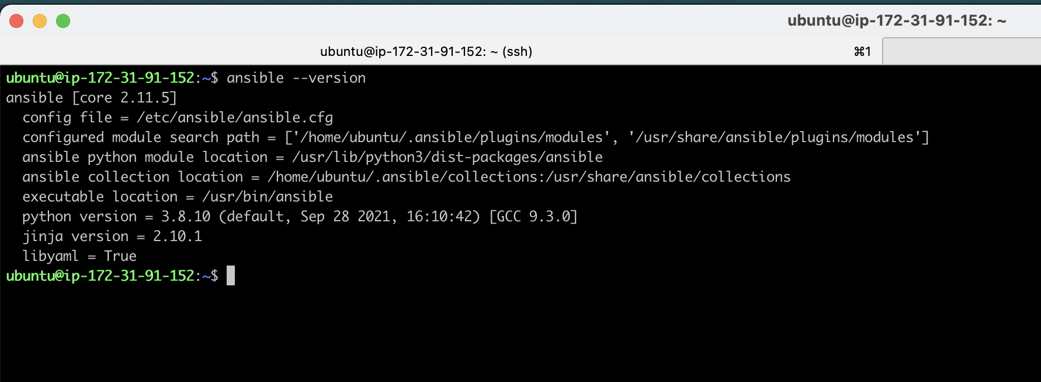

Docker installation using Ansible

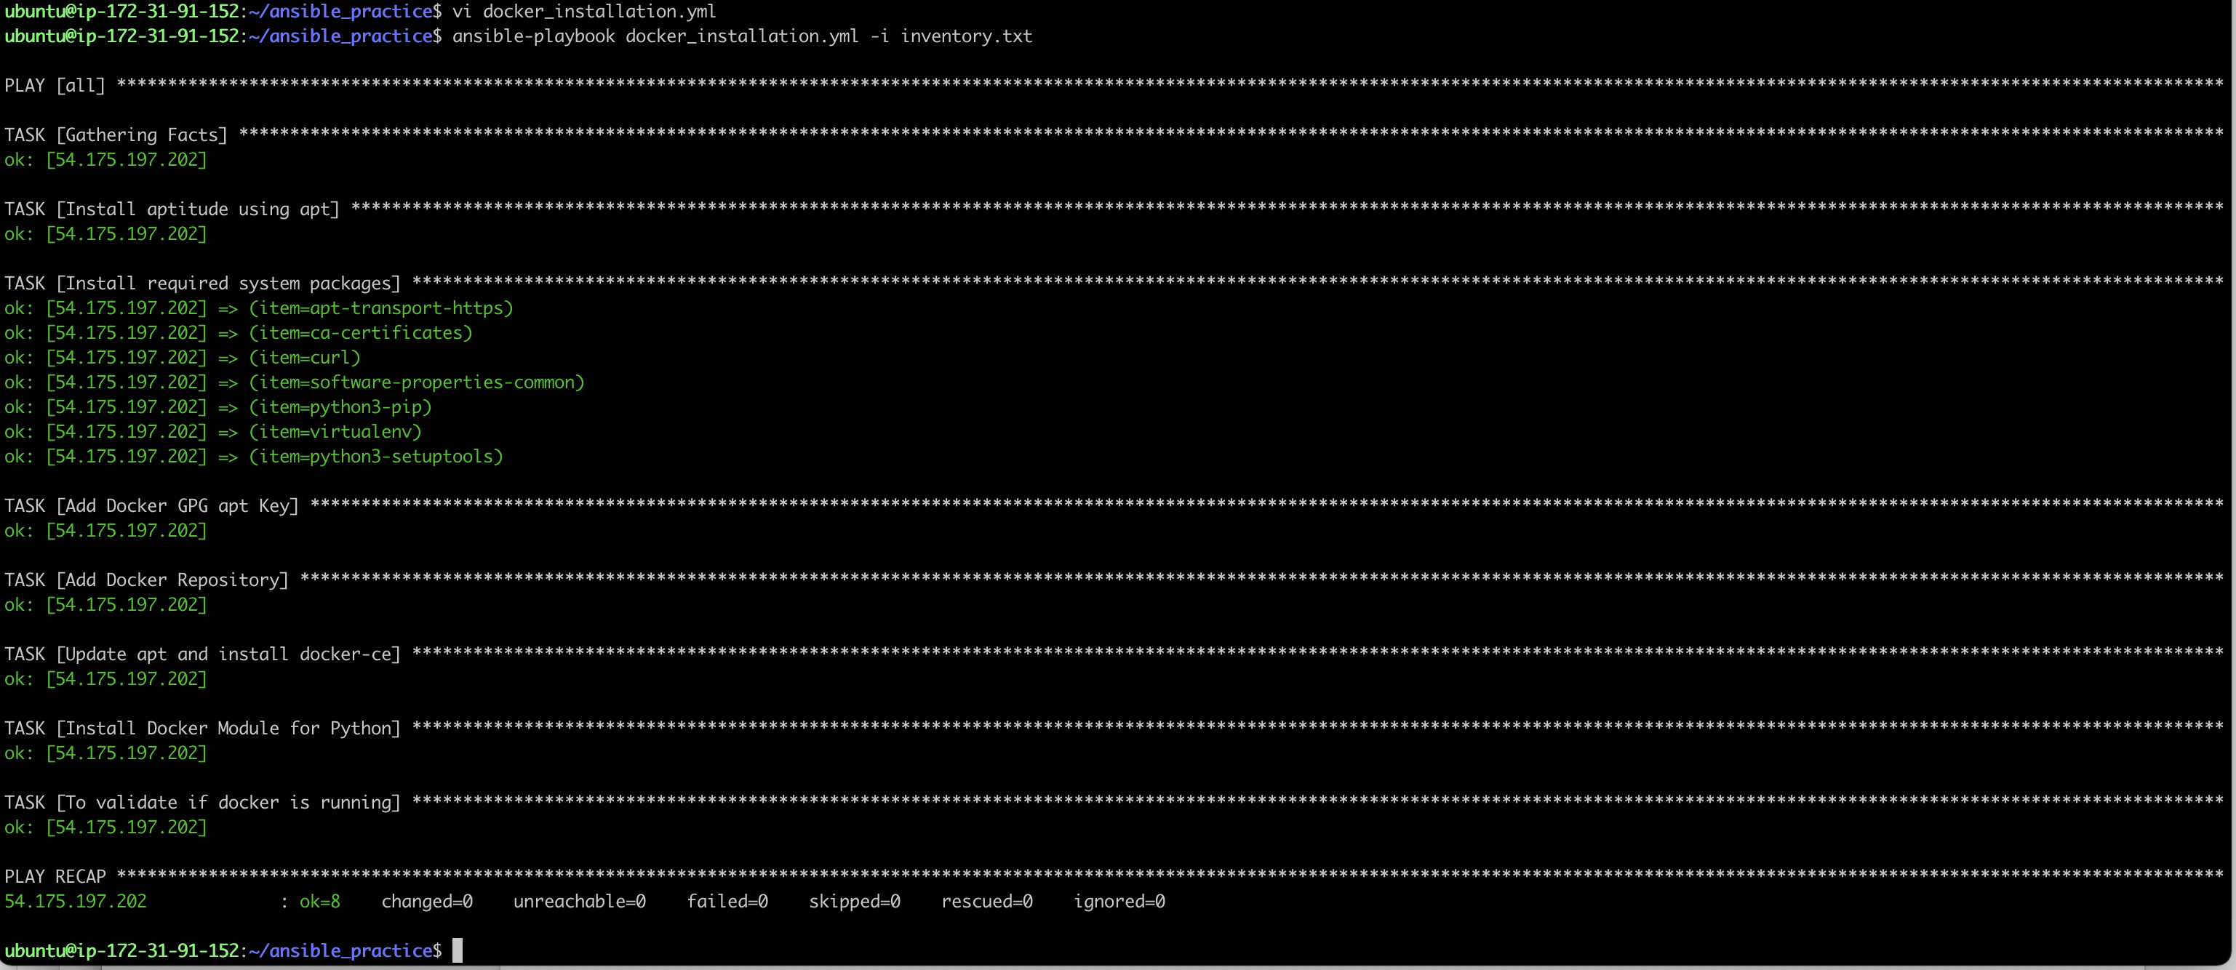

Subtask-2

ALB

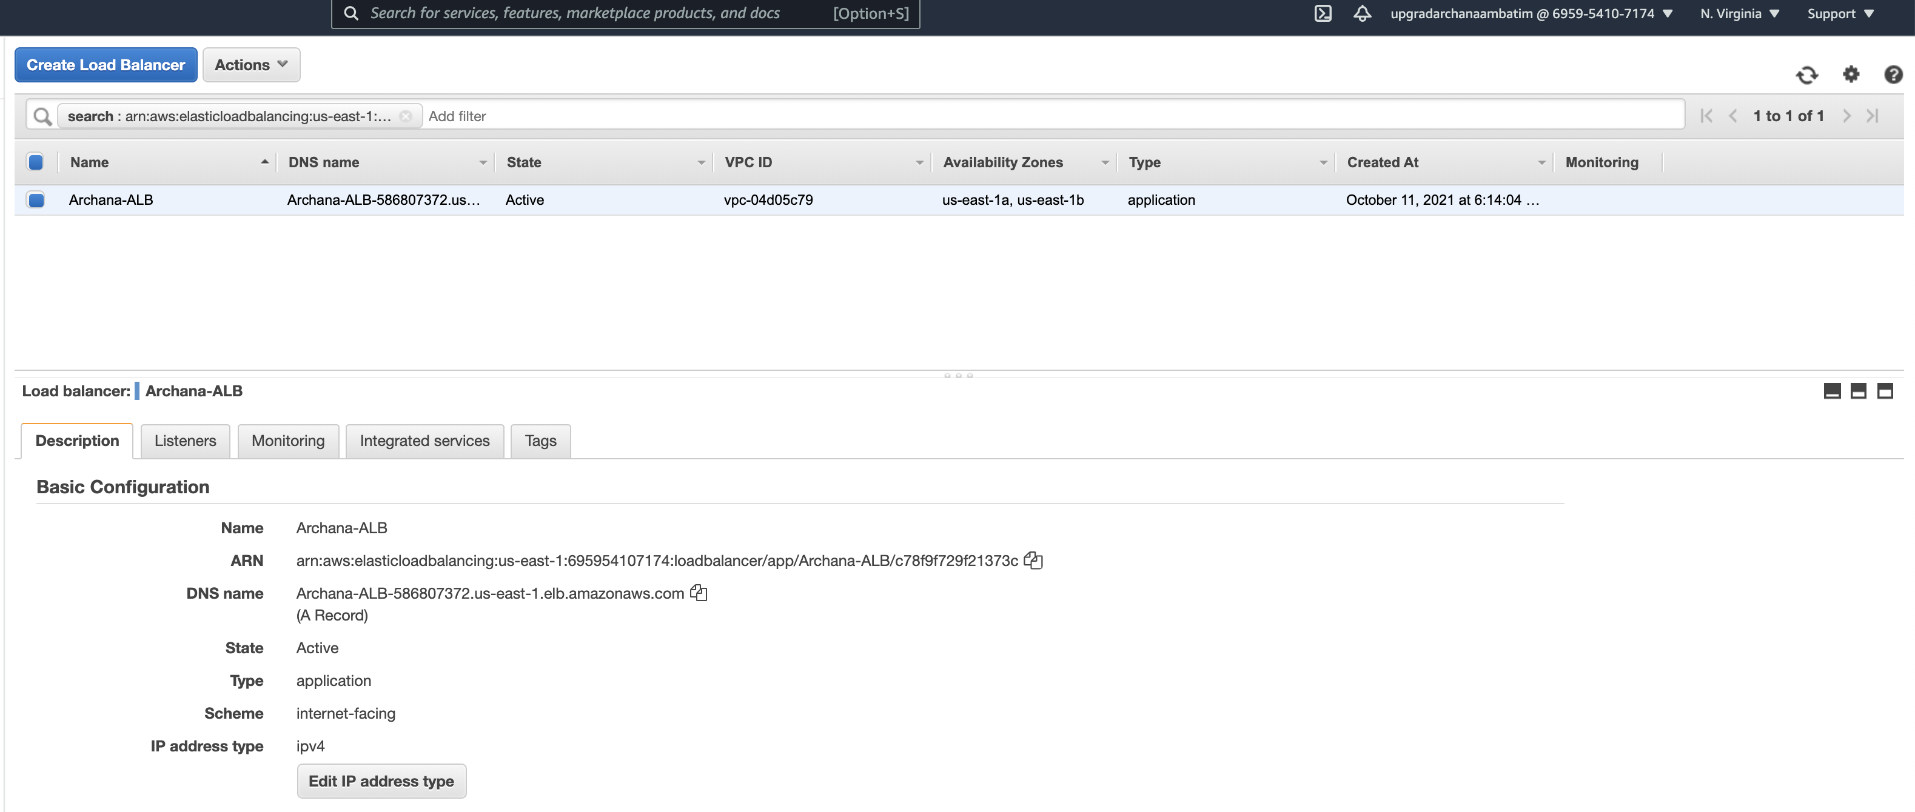

ALB Security group (created in task-1)

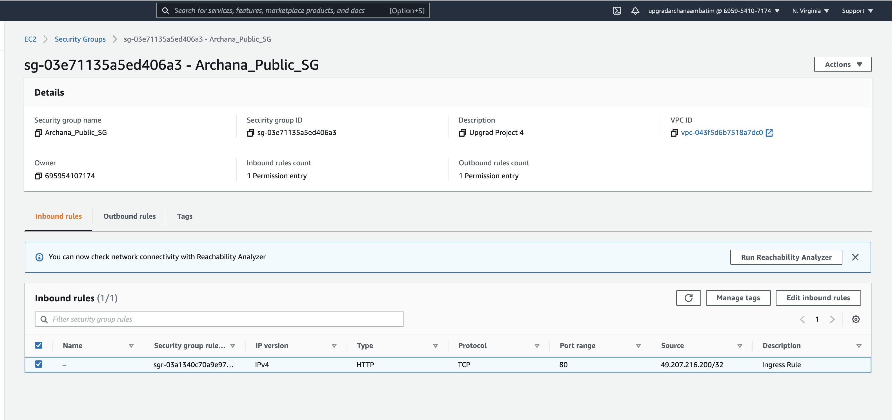

Jenkins installation

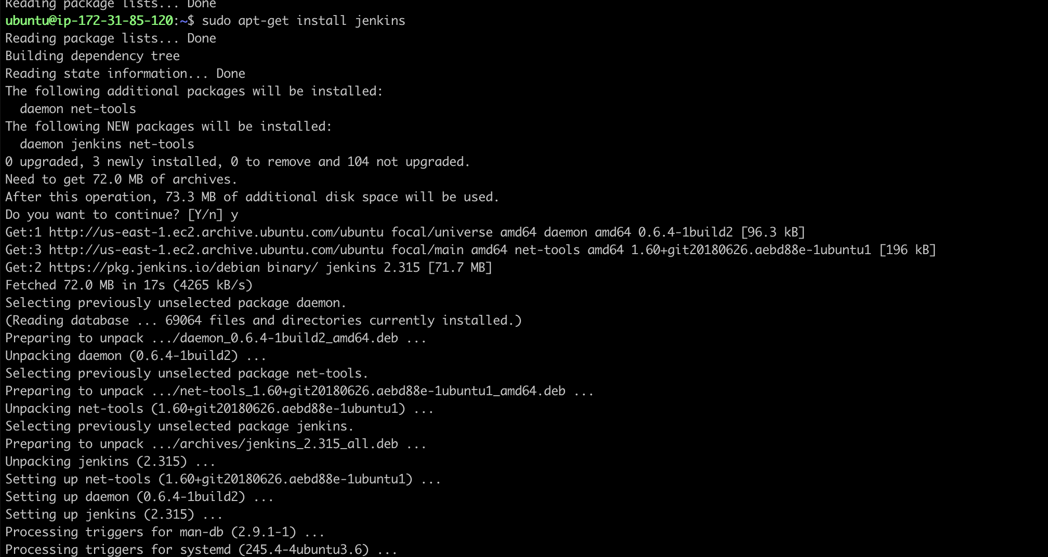

User creation

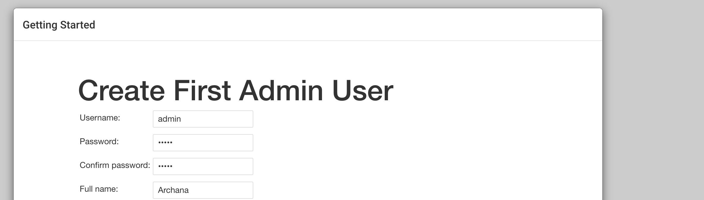

Jenkins config change for prefix

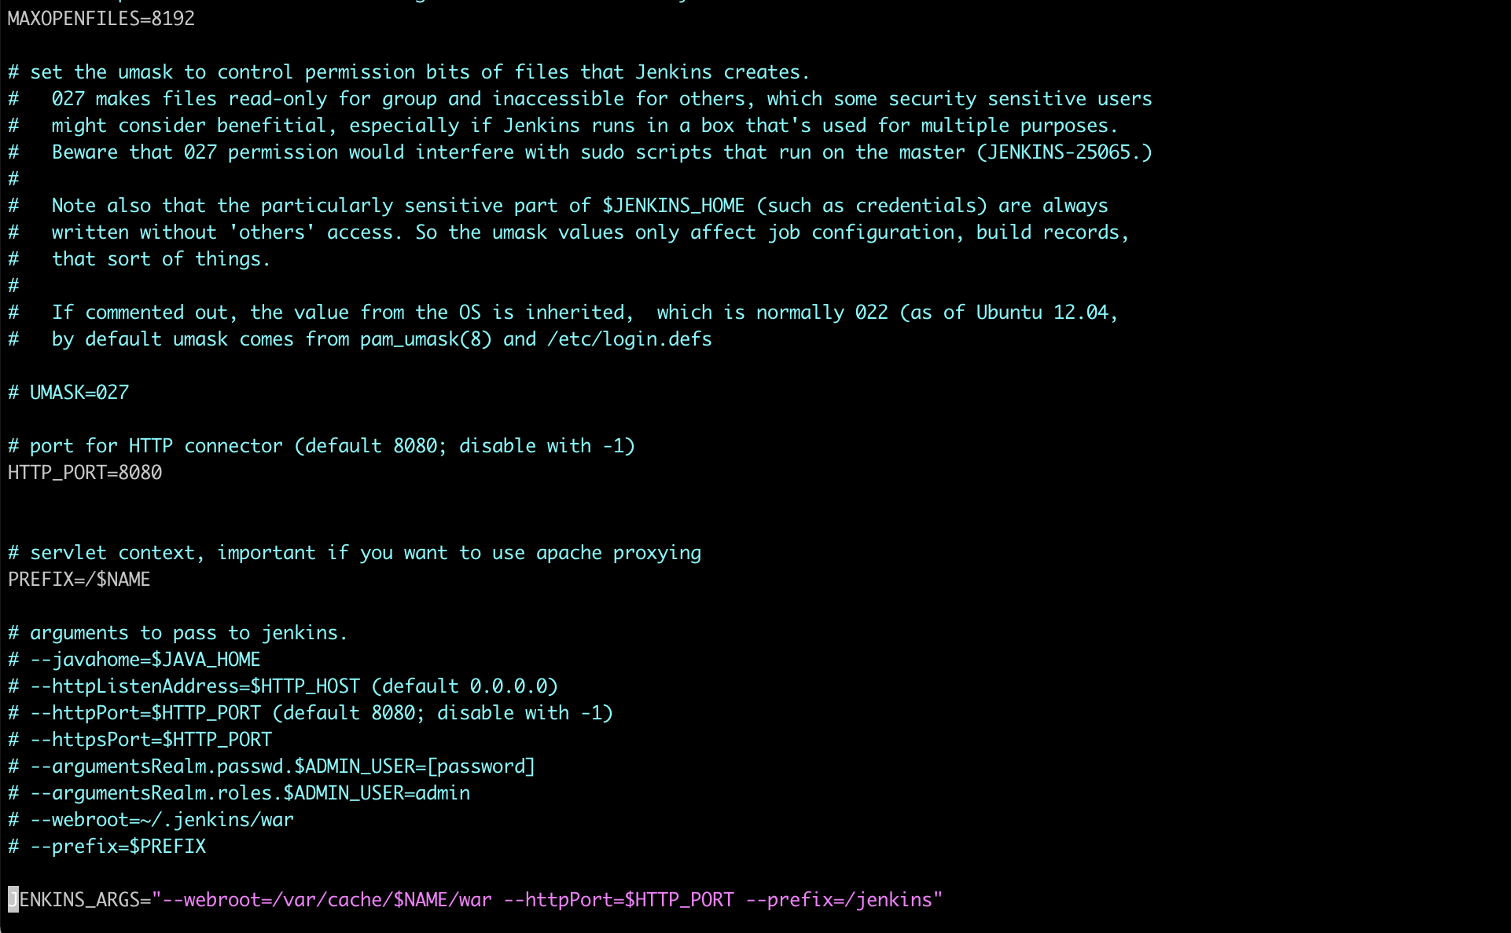

Accesing Jenkins using load balancer

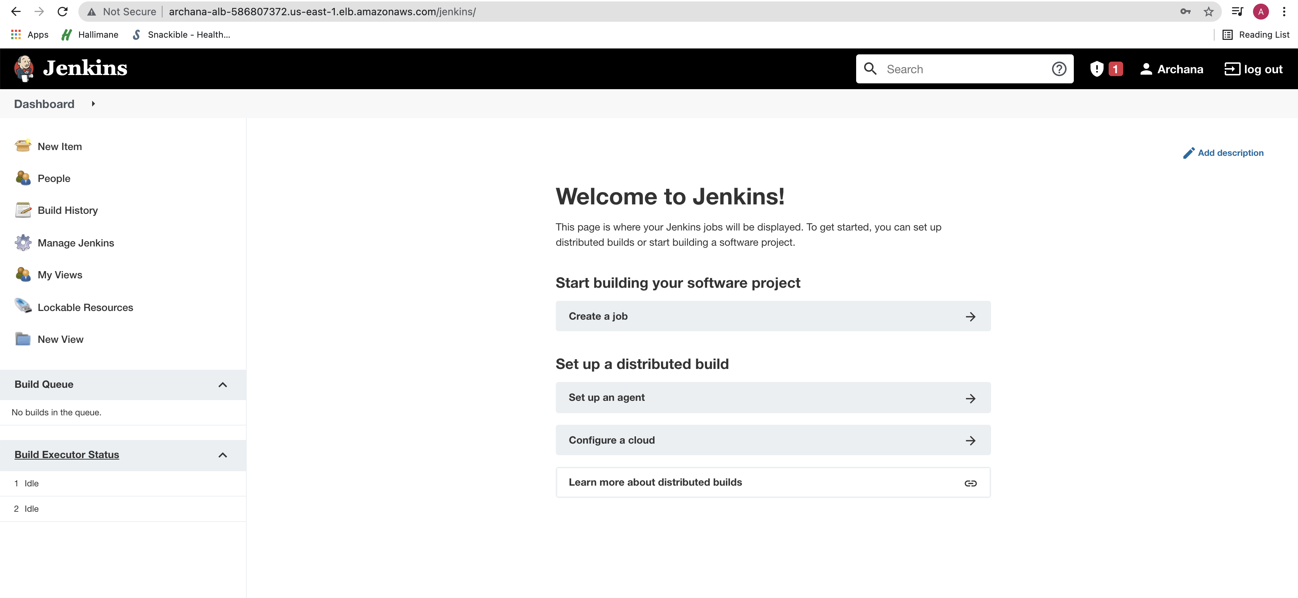

Subtask -4

ECR Repository

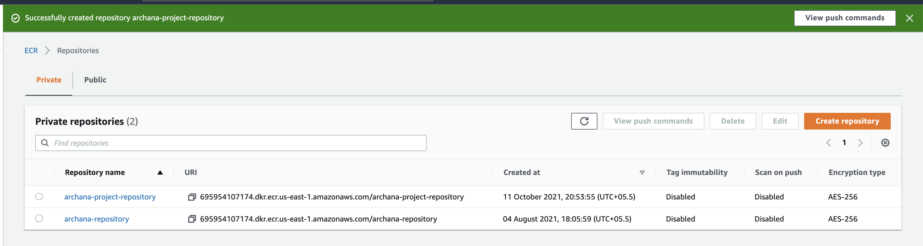

IAM Role

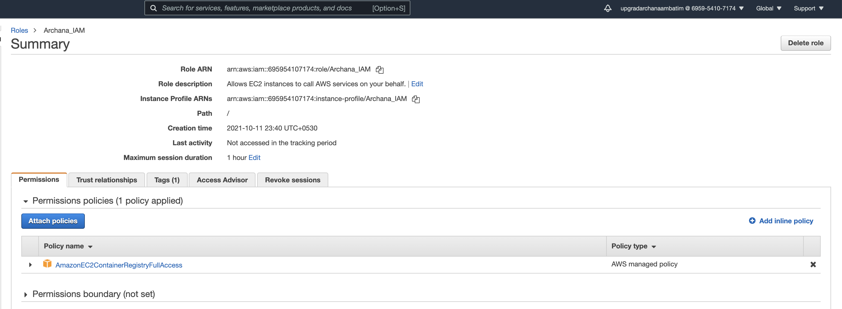

ECR Repository Authentication



SSH Connection to APP server

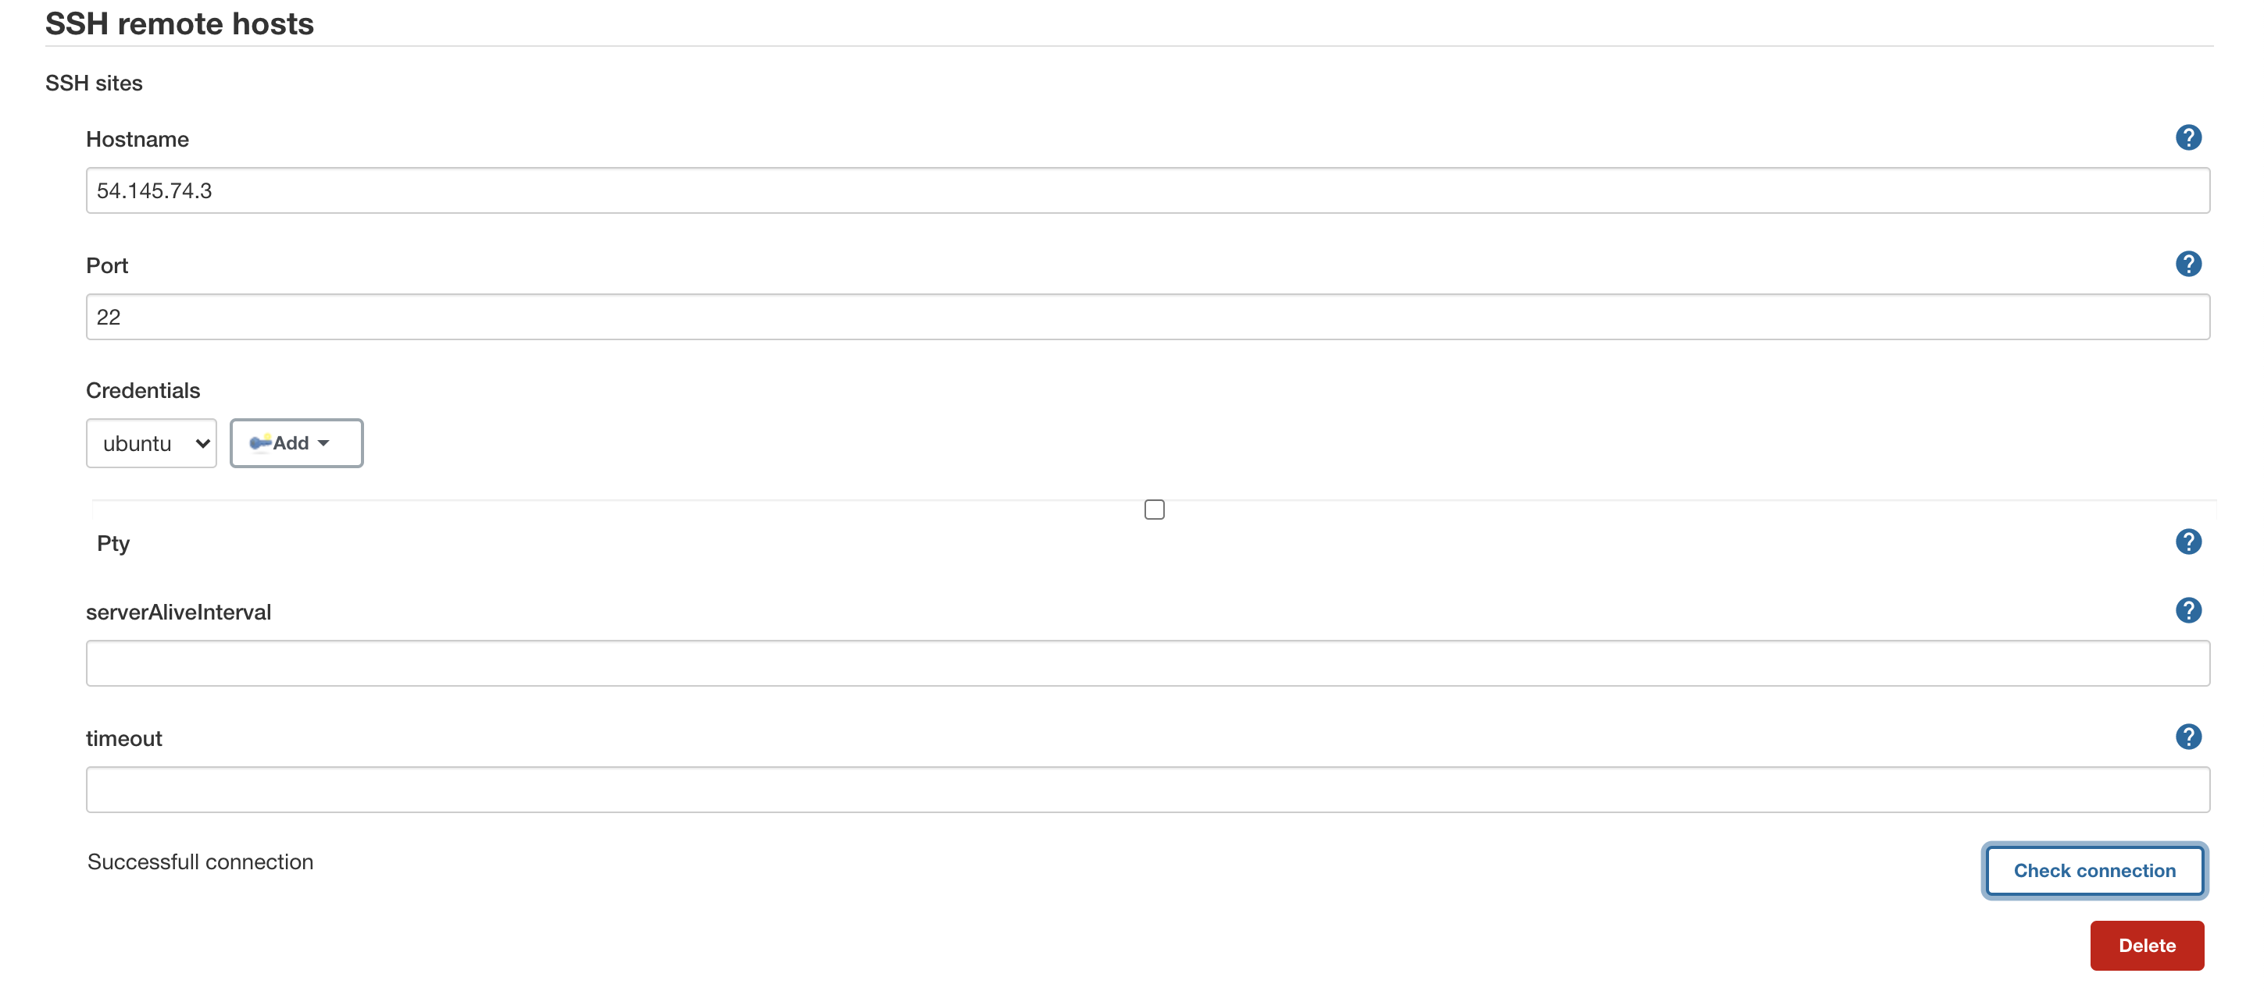

Sample job to ssh to app and create a file (To validate Jenkins installation and connectivity)

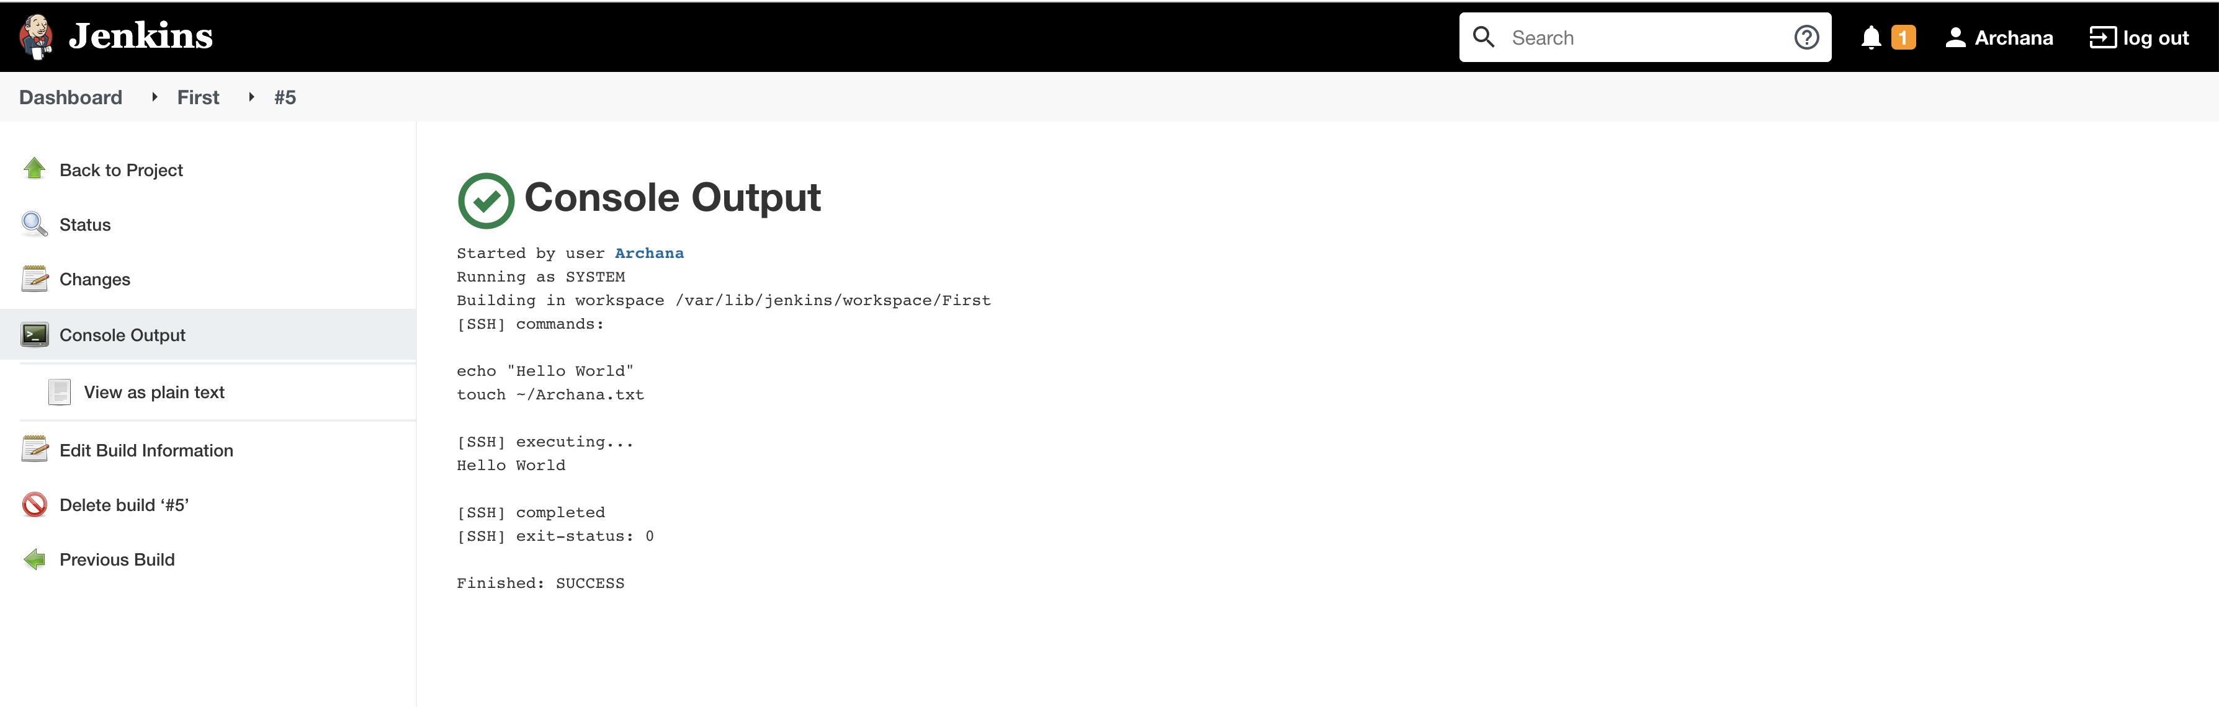

**Task3**

Subtask-1

Github Repo

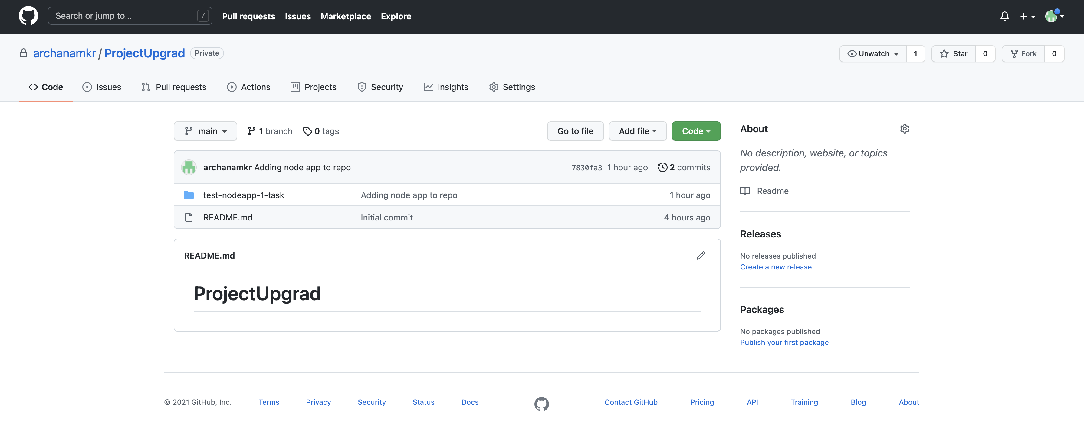

NODE app testing in local env

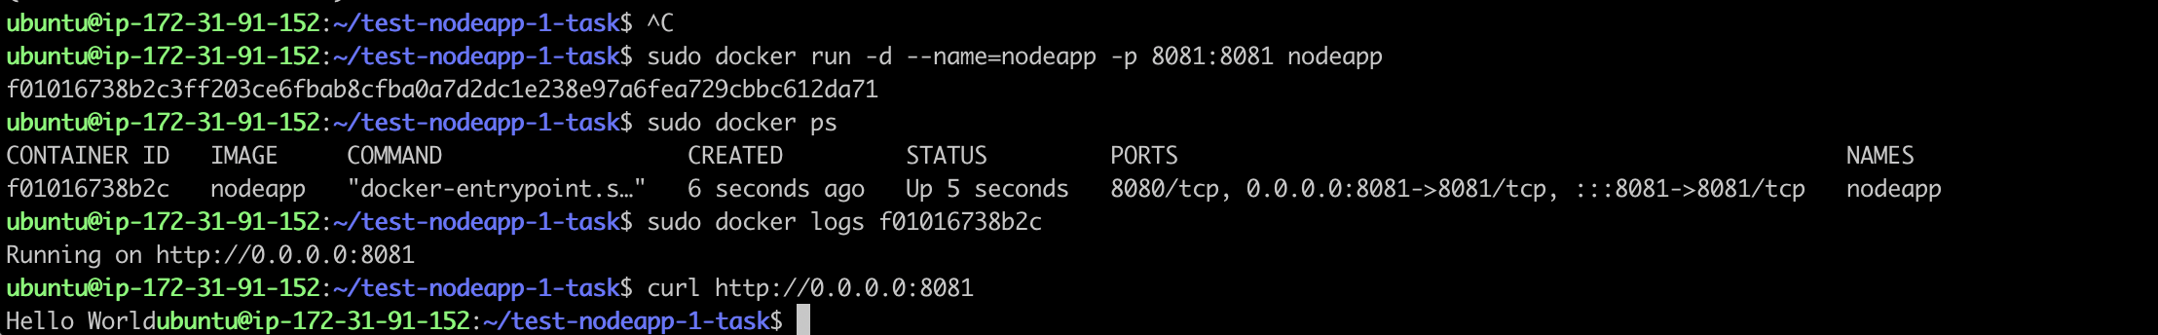

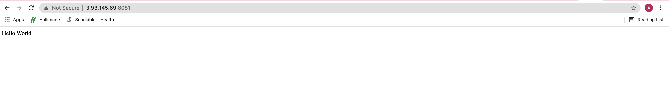

Adding Docker File to github repo

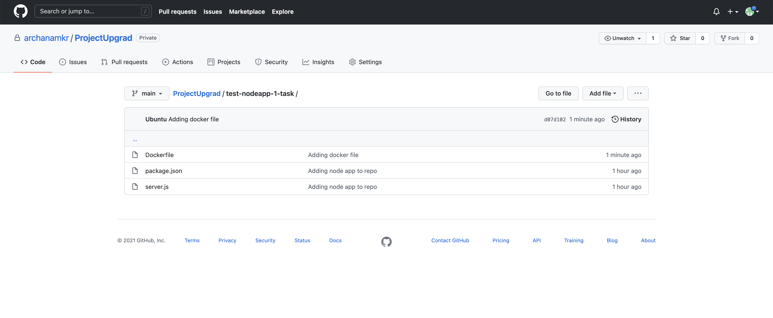

Credentials in Jenkins

